1. Create a maven project

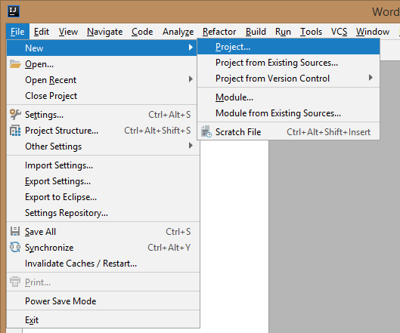

1. Choose maven

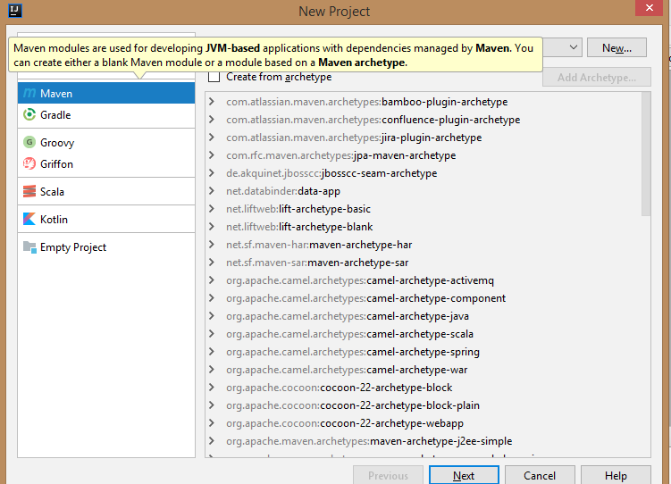

1. Click Next
2. Enter GroupId and Artifact

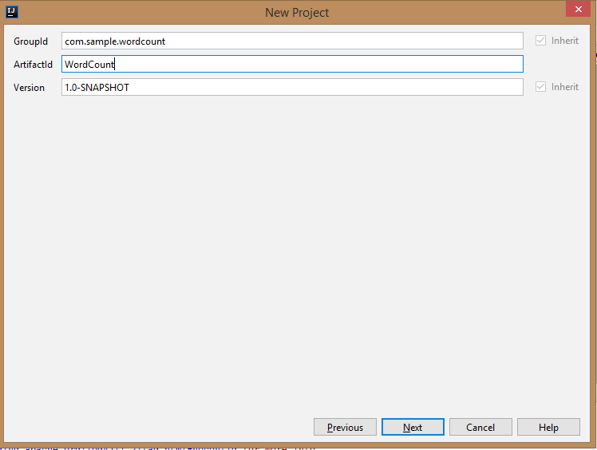

1. Select target directory for project

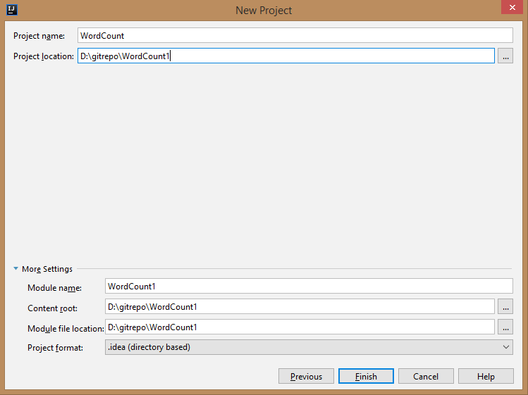

1. Enable auto import on bottom right corner

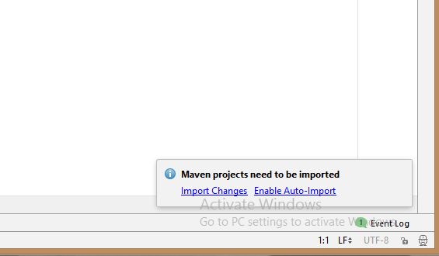

1. Copy following code and paste it in pom.xml file just before </project> tag

*<dependencies>*

*<dependency>*

*<groupId>org.apache.hadoop</groupId>*

*<artifactId>hadoop-common</artifactId>*

*<version>2.6.2</version>*

*</dependency>*

*<dependency>*

*<groupId>org.apache.hadoop</groupId>*

*<artifactId>hadoop-mapreduce-client-common</artifactId>*

*<version>2.6.2</version>*

*</dependency>*

*</dependencies>*

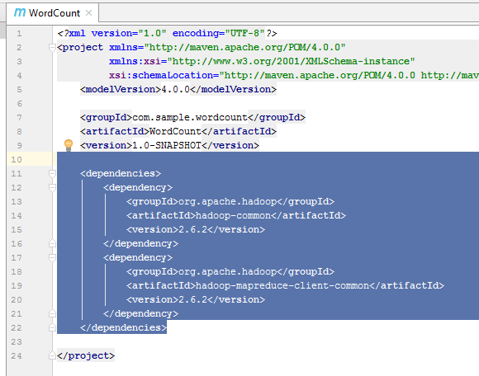

1. Copy WordCount.java file under the package
2. Configure intellij to generate a JAR file as following

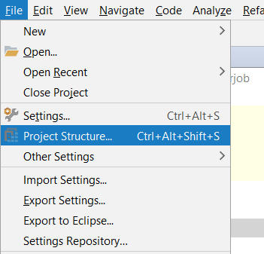

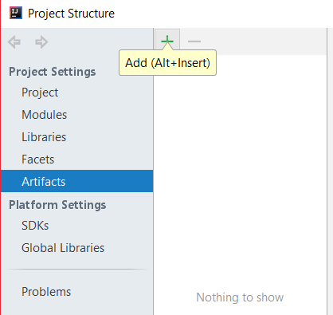

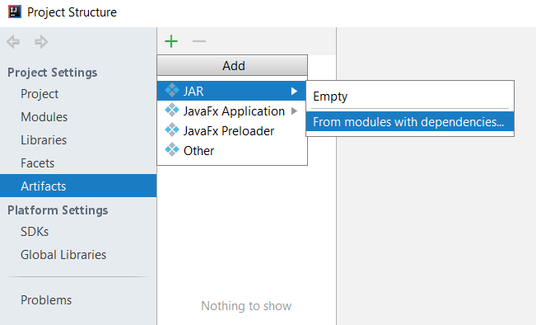

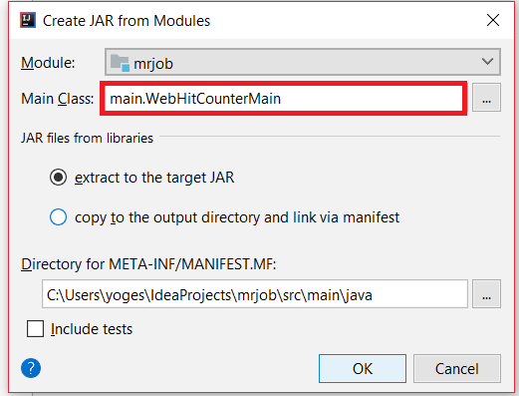

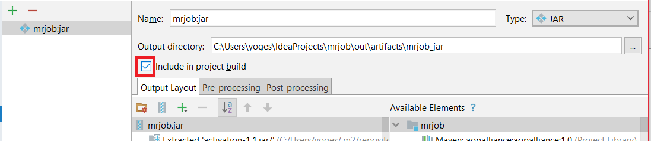

1. Click OK
2. Build your JAR file by following

**Build -> Rebuild Project**

On main menu

1. You will find your JAR file in out directory:

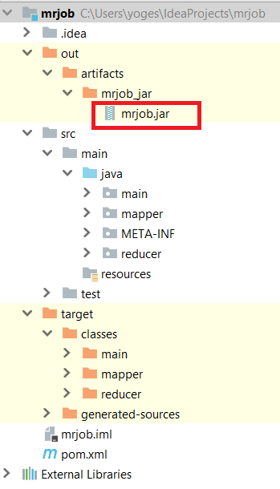

1. Get this JAR into your VM and run it

References:

<https://mvnrepository.com/artifact/org.apache.hadoop>

<https://stackoverflow.com/questions/26975818/what-is-scope-under-dependency-in-pom-xml-for>

<https://stackoverflow.com/questions/1082580/how-to-build-jars-from-intellij-properly>